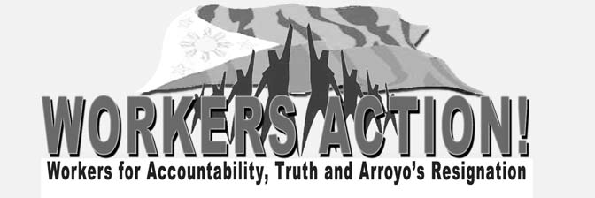

Statement of Workers’ Unity for the
Resignation of President Gloria Macapagal-Arroyo

We are workers, employees, unionists and members of the urban poor, drivers-small operators and vendors who come together to stand and work together for the resignation of Gloria Macapagal-Arroyo as President of the Philippines. We say: Enough of Gloria’s corruption and plunder, oppression, and repression of the Filipino people! Enough of her crimes against the people!

Enough of Gloria’s corruption and plunder! Jose Pidal account, Diosdado Macapagal Boulevard, Joc-joc Bolante and fertilizer scam, Comelec computerization program, North Rail and South Rail projects, Cyber-Education Project, and NBN-ZTE – these have been the words and phrases for corruption and plunder under the Arroyo administration. In all of these, no venue for truth and accountability has been provided by the government: No credible investigation has been launched, no government official has been put behind bars. What we see are evidences that point to the culpability of Mrs. Arroyo, her family and closest allies in government. What we see are attempts of this government to hide the truth and evade accountability.

Enough of Gloria’s oppression of the Filipino people! Landlessness, high prices, low wages and salaries, retrenchment and contractualization, demolition of homes, poor basic services -- these are the daily experiences of the Filipino people under Gloria’s administration who continue to serve only the interests of foreign capitalists and her cronies.

Enough of Gloria’s repression of the Filipino people! Extra-judicial killings of more than 800 people, enforced disappearances, union busting, strike busting, militarization in workplaces and urban poor communities – these have been the responses of the Arroyo administration to those who dared to oppose her anti-workers and anti-people policies. In all of these, no thoroughgoing investigations have been made. We only hear her retinue of cabinet officials and top generals doing official denials. What we see are the policies of this government to silence her critics and continue to cling to power.

We who produce wealth for the country, yet are made even poorer by the policies of her administration, unite with other sectors in saying “Tama na!” We who form part of the Filipino people, yet are always at the losing end of her anti-people, anti-national measures, unite with other sectors in saying “Sobra na!” We who barely live by the fruits of our unremitting labor, yet are always the victims of corruption and plunder in government, unite with other sectors in saying “Gloria, Resign na!” ###

